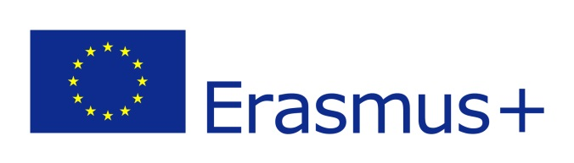

(Photograph)
PROGRAMME ERASMUS + ICM

STUDENT APPLICATION FORM

ACADEMIC YEAR: 20…... / 20…..
FIELD OF STUDY: ……………………………………………………

SENDING INSTITUTION: ……………………………………………………………………..
Departmental coordinators – name, telephone and telefax numbers, e-mail :
………………………………………………………………..………………………………………………………………
………………………………………………………………..………………………………………………………………
………………………………………………………………..………………………………………………………………
Institutional coordinator – name, telephone and telefax numbers, e-mail :
…………………………………………………………………………………………………………………………………………

STUDENT’S PERSONAL DATA

(to be completed by the student applying)
Family name : | First name (s) :
Date of birth :
Sex : M / F Nationality : | Place of birth :
Email address:
Current address : | Permanent address (if different) :
Current address is valid until :
Tel. nr (incl. country code nr.): | Tel. nr (incl. country code nr.):

LIST OF INSTITUTIONS WHICH WILL RECEIVE THIS APPLICATION FORM (in order of preference):
Institution | Country | Period of study |  | Duration of stay (months) | No. of expected ECTS credits
 |  | From | To
1.

2.

3.

Name of student:
Sending institution : ……………………………………………………………………………… Country : ………………………………….
Briefly state the reasons why you wish to study abroad:
……………………………………………………………………………………………………………………………………………………………………………………………………………………………………………………………………………………………………………………………………………………………………………........……………………………………………………………………………………………………………………………………………………………………………………………………………………………………………………………………………

LANGUAGE COMPETENCE
Mother tongue : ………………..... Language of instruction at home institution (if different): ………………………………
Other languages | I am currently studying this language |  | I have sufficient knowledge to follow lectures |  | I would have sufficient knowledge to follow lectures if I had some extra preparation
 | YES | NO | YES | NO | YES | NO

WORK EXPERIENCE RELATED TO CURRENT STUDY (if relevant)
Type of work experience | Firm / Organization | Dates | Country

PREVIOUS AND CURRENT STUDY
Diploma/degree for which you are currently studying :
PTYCHIO (Bachelor of 4 years - 240 ECTS) MASTER (4 semesters - 120 ECTS)
MASTER (3 semesters - 90 ECTS) MASTER (2 semesters - 60 ECTS)
MASTER (1 academic year - 75 ECTS) DOCTORAL degree
Number of higher education study years prior to departure abroad (min 1): …………………………………..
Have you already been studying abroad? Yes No
If Yes, when ? at which institution ? …………………………………………………………………………..

Student’s Signature……………………………………………………………… Date:…………………………..

RECEIVING INSTITUTION
We hereby acknowledge receipt of the application, the proposed learning agreement and the candidate’s Transcript of records.
The above-mentioned student is
- provisionally accepted at our institution
- not accepted at our institution

Departmental coordinator’s signature Institutional coordinator’s signature

…………………………………….. …….. ………………………………………………………………………
Date : ……………………………….…… Date : …….…………………………..

